**HONG KONG POLYTECHNIC UNIVERSITY**

ENG1003 Freshman Seminar for Engineering

Report on

Design of Path Planning Algorithm for Aircraft Operation

By

AAE Group 8

Kam Ho LEUNG (Howard)

Lok Hei NG (Lochlan)

Pak Ho CHAN (Parco)

Hoi Ki TSANG (Helen)

Yat Chi KHIM (Jimmy)

**Table of Contents Page No.**

Background of Path Planning to Aviation Engineering 2

Theory of Path Planning Algorithm 2

Introduction of the Engineering Tools 3

1. Python
2. GitHub

Task 1: Finding the PolyU Aircraft Model that achieve the minimum cost 4

1. Methodology
2. Results
3. Discussion

Task 2.1: Finding the PolyU Aircraft Model that achieve the minimum cost 7

(4 constraints with 2 variables)

1. Methodology
2. Results
3. Discussion

Task 2.2: Finding the PolyU Aircraft Model that achieve the minimum cost 8

(4 constraints with 6 variables)

1. Methodology
2. Results
3. Discussion

Task 3: Designing a new cost area that can reduce the cost of the route 10

1. Methodology
2. Results
3. Discussion

Reflective Essay 11

Reference 16

**Background of Path Planning to Aviation Engineering**

In aviation, Airline Route Planning is nothing more than planning on the proposed flight route. It involves calculating the amount of fuel needed by the aircraft to fly from the original airport to the destination airport, planning the flight with the most reasonable route and meeting the requirements of Air Traffic Control to prevent collisions. Pilots have to do the flight planning before each flight, considering the weather conditions, the weight of the aircraft at different stages, length and altitude of the hold flight, and the rules set by ICAO for safe planning.

From the operation point of view, path planning is vital in Air Traffic Management of commercial airlines. Generally, airlines would try to minimize flight cost by choosing the appropriate route, altitude, and speed, and by loading the minimum necessary fuel on board. Thus, a well-planned path can minimize fuel consumption economically and lower each flight's cost under safe conditions. In the meantime, the consumption of fuels is directly proportional to the release of carbon dioxide gas. Therefore, a well-planned flight path can also protect the environment.

Pilots need accurate weather forecasts to calculate the fuel consumption of air temperature and the direction of the wind. A tailwind, which blows in the direction of travel of the aircraft, reduces the use of fuel. However, a headwind, which blows against the direction of travel of the aircraft, increases the fuel consumption because the speed of aircraft decreases, causing the extension of the flight time. Furthermore, all aircraft must follow the predetermined routes assigned by Air Traffic Control to ensure they are separated in a safe distance. Such routes may not as economical as a direct flight, which means more fuel is consumed. It can be seen that path planning is a complicate process which involves millions of calculations with no rooms for error. A licensed flight dispatcher is required by law to carry out flight planning.

**Theory of Path Planning Algorithm**

Path planning is used to find a sequence of valid configurations that moves the object from the source to the destination [1]. It consists of two parts: creating a search space including all possible paths, which can avoid any obstruction, terrain or threat between two points, and searching the best path which satisfies the constraints in different missions.

The motion is represented as a path in a configuration space, which is the set of all possible configurations. The configurations can be represented by different numbers of parameters, depends on the shape of the object and dimension of workspace. For instance, the configurations can be acted for two parameters (x, y) if the object is a zero-sized point translating in a two-dimensional workspace [2]. If a 3D object undergoes translation and rotation in a three-dimensional workspace, then the configuration requires six parameters (x, y, z) for translation and Euler angles () for rotation [2]. Inside a configuration space, there are free space and obstacle space. The former is the space which avoids collision with obstacles while the latter is the space to which the object cannot move.

The object has to find the shortest path to pass through the target space and dodge all obstacles. It has different methods to search for it. In this project, A* is commonly used because of its completeness and optimal efficiency. It is a path planning algorithm which often uses in the computer field. A* is formulated in a weighted graph, starting from entering a specific starting node [3]. Then the goal node has to be entered, so the computer will search for a path which has the smallest cost between two nodes by maintaining a tree of paths and expand one neighbouring path each time until its termination criterion is met [3]. The process of generating a path by A* can simplify as when each time it enters a node, it calculates the total costs of each neighbouring node by formula where is the next node on the path. It then enters the node with the lowest costs.

**Introduction of the Engineering Tools**

1. **Python**

Python was created in 1991 by Dutch programmer Guido van Rossum [4]. Python is an interpreted programming language as python is handled at runtime by the interpreter, which means people do not need to translate and edit the program before implementing it [5]. Python is also interacting as people can use the Python prompt to write code and interact directly with the interpreter to write programs. Python is object-oriented because Python supports object-oriented styles and programming techniques that encapsulate code in objects.

Python is the most common programming language. There have several reasons. One of the reasons is easy to learn because Python has few keywords, simple structure and exact syntax [5]. This allows people to master the language quickly. It is also easy to read as Python code is more clearly defined and visible to the eyes. Another reason is that it is easy to maintain as the python source code is easy to maintain. The python has extensive standard library as the massive amount of python libraries have high portability and cross-platform compatibility on UNIX, Windows and Macintosh [4]. Python is an excellent language for entry-level programmers that supports the development of various applications from simple text processing to WWW browsers to games [5]. The python programming language can build many types of programs. For example, the python can build cloud-based apps, games in both 2D and 3D and business apps which can capture, analyze, and process data. Python is very close to our daily life as it also can build mobile apps.

1. **Github**

An American multinational company founded GitHub [6]. It provides hosting for software development and version control using Git. It also provides distributed version control of Git and source code management (SCM) functions. It provides access control and multiple collaboration functions for each project, such as error tracking, feature request, task management and continuous integration. It is headquartered in California, and it has been a subsidiary of Microsoft since 2018.

The Github has five essentials: repositories, branches, commits, pull requests, Git. A repository is used to store development projects, and resources want to share. It can contain folders and many types of files such as HTML, CSS, JavaScript, documents, data and images [7]. It also includes a license file and a readme file about the project. GitHub branches are used to process different versions of repositories at the same time. The repository has a master branch to default. Other branches are the copy of the master branch as at a point in time [7]. The new branch is used for bug fixes, and its practical work is separated from the main branch. They can be merged into the master branch when the changes are ready. If there are changes to master brunch while using the new branch, these updates can be pulled in [7]. Each commit has a description explaining the reason for the change.

Pull requests are the core of collaboration of GitHub. The changes can merge with the master branch with the pull request. The pull request shows the content difference, change, additions, and subtractions in green and red colours. After creating a commit, a pull request can be opened and started discussion before the code. Git is the core of Github which is an open-source project started by Linux creator Linus Torvalds. Git is similar to other version control systems for managing and storing project revisions [7]. Although Git is mainly used for code processing, it can also be used to manage other types of files such as Word documents or Final Cut projects. It acts as a filing system for every draft of a document.

**Task 1: Finding the PolyU Aircraft Model that achieve the minimum cost**

## **Methodology**

The objective of Task 1 is to find the minimum achievable cost of each given aircraft (in the form of parameters) (Figure 3) for the map given to the group (Figure 1), given implementation of the A-Star pathfinding algorithm in the form of a Python script file.

In the Python pathfinding source code given, the map and the parameters of the aircraft are embedded (Figure 5, 6). Therefore, to complete task 1, the map given in the source code (Figure 2) must first be modified to match that of the map given for the group. The group must then test the cost of the aircraft models given by the professor by also modifying the aeroplane parameters in the source code and running the Python algorithm with the modified aircraft parameters. The results are then outputted to the terminal after executing the algorithm (Figure 4).

The map is constructed in lines 283-325 of the source code (Figure 5). The values for the grid, start point, endpoint, obstacles, time-consuming regions, and fuel-consuming regions are edited to reflect the placement of each element. For instance, lines 284 and 285 are modified to place the start point to that indicated in Figure 1.

The aircraft parameters are defined in lines 49-56 of the source code. However, unlike the parameters for the map, which is unchanged throughout Task 1, the aircraft parameters would be changed multiple times in the process of Task 1, to test for the costs of different aircrafts listed In Figure 6. A mechanism to take user input as command-line arguments is then implemented (Figure 7) as creating one file for each aircraft in Task 1 would be superfluous.

To obtain the test result for each aircraft using the modified Python script, the script should be executed with parameters for the aircraft given after the filename, in the sequence of *CF, ∆F, CT, ∆T, Cc, ∆Fa ∆Ta* (Figure 8).

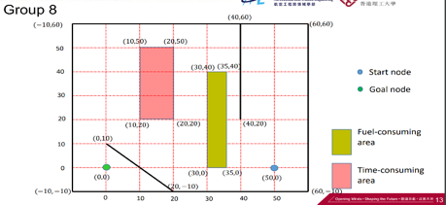

Figure 1, the map given for task 1.

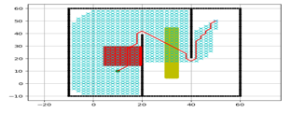

Figure 2, the map in the Python source code given.

, the map in the original source code., the

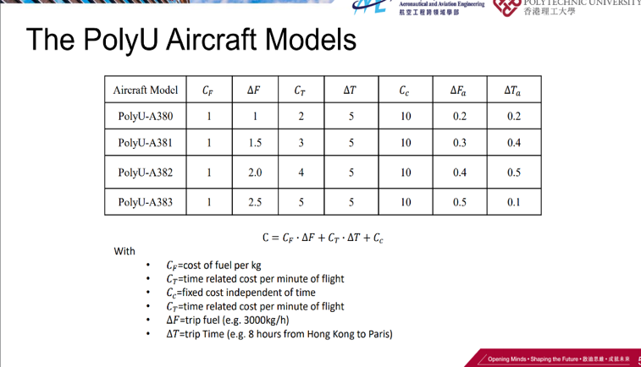

Figure 3, list of aircraft models to be tested in Task 1.

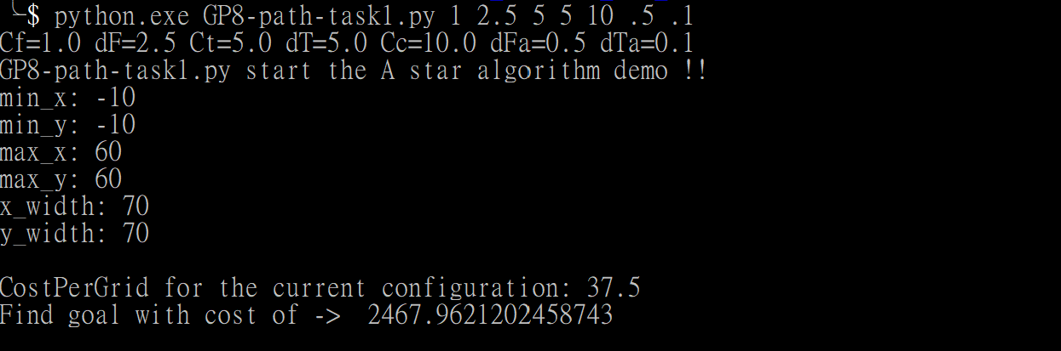

Figure 4

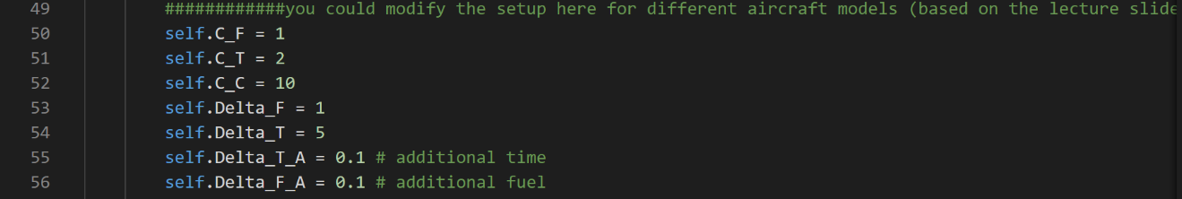

Figure 5, aircraft parameters

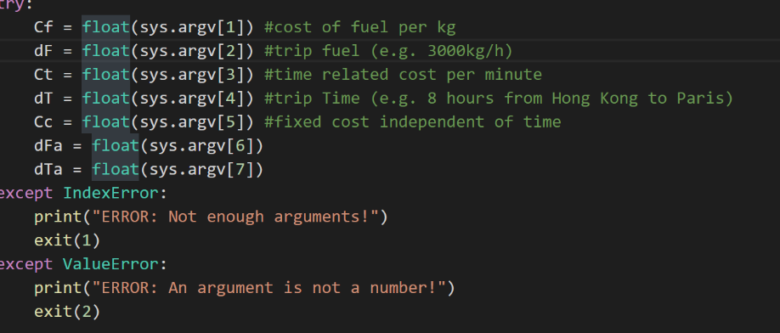

Figure 6

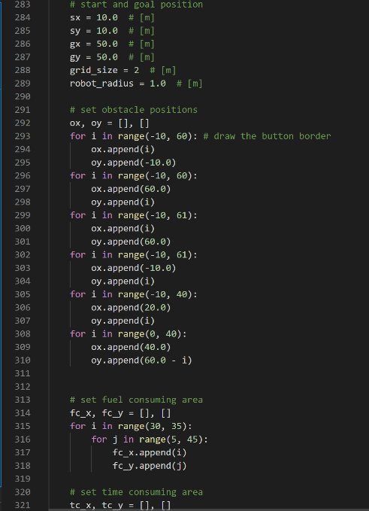

Figure 7, map parameters



Figure 8, example for PolyU-A380

## **Results**

The results of the minimum achievable cost for each aircraft given in Figure 3 are obtained after executing the Python script with appropriate parameters. The results are as follows.

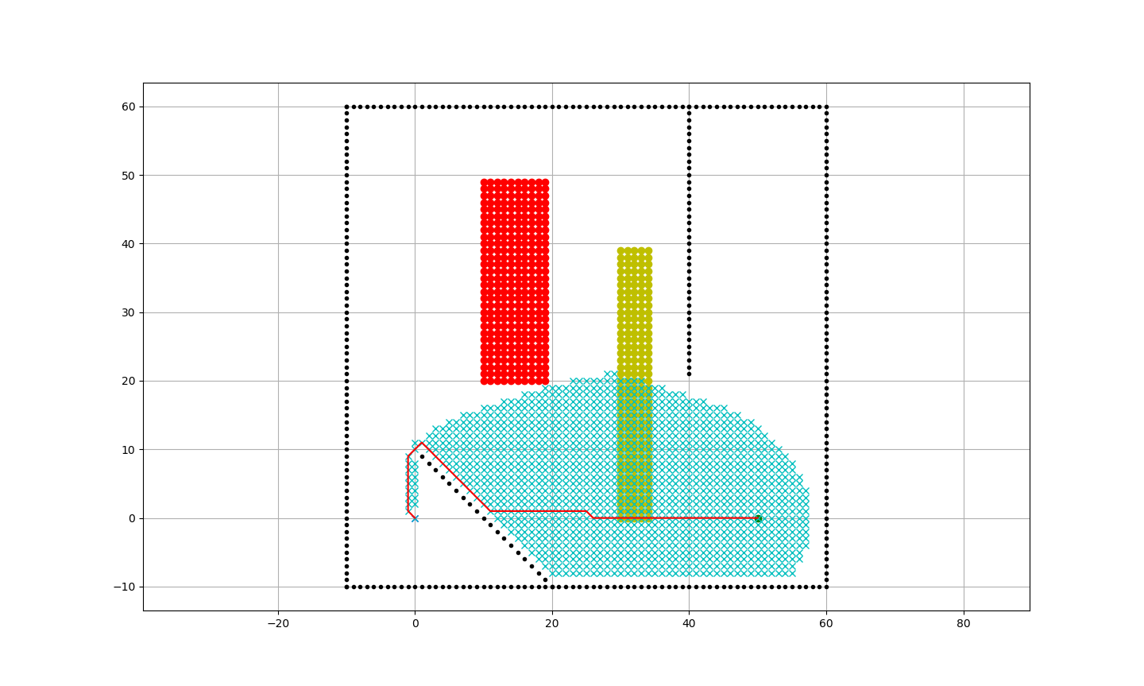

Figure 9

### PolyU-A380

Cost obtained: 1382.78 (Figure 9)

### PolyU-A381

Cost obtained: 1745.67 (Figure 10)

### PolyU-A382

Cost obtained: 2108.07 (Figure 11)

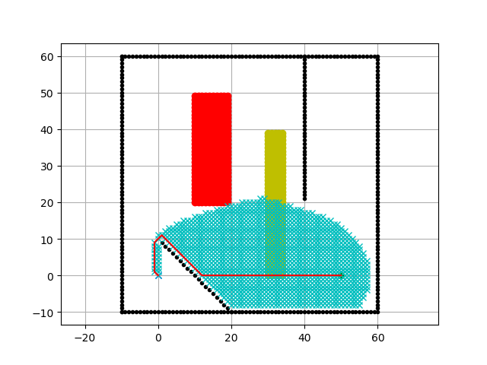

Figure 10

### PolyU-A383

Cost obtained: 2467.96 (Figure 12)

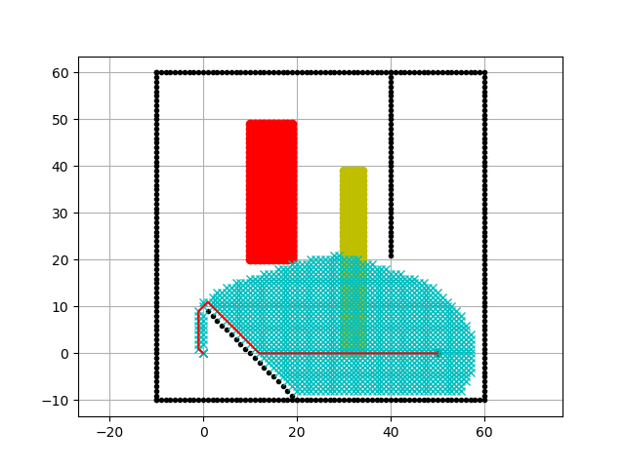

Figure 11

## **Discussion**

The goal of this test is to find the aircraft model with the lowest cost in the scenario given. Initially, the hardest thing for the group is to familiarize different function of the components of the code. The group then only need to complete the task by inputting the data of corresponding aircraft models to get the result, by finding out that the aircraft does not pass through the time-consuming area. We realize that the fuel-consuming area is the only factor affecting the overall cost, with aircraft model A380 has the lowest additional fuel consuming cost, we find the result. Overall, the difficulty of the task is not the highest among the three tasks given, but some aspects of Task 1, such as implementing the map, and understanding the algorithm, is beneficial to the group, in that it allows for the rapid development of the future tasks.

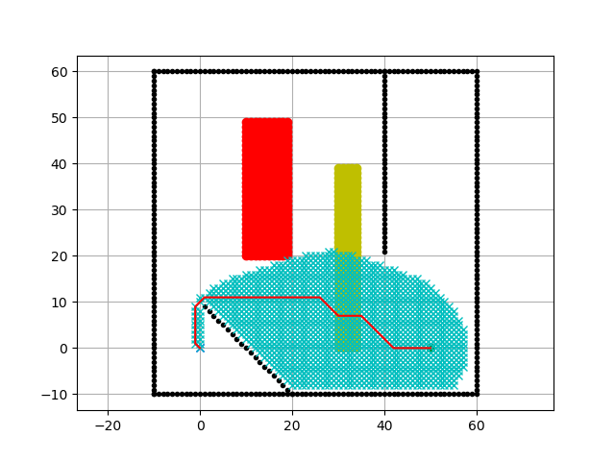

Figure 12

**Task 2.1: Finding the PolyU Aircraft Model that achieve the minimum cost**

**(4 constraints with 2 variables)**

1. **Methodology:**

In task 2.1, our goal is to design a new aircraft model within the constraints and 2 variables (Cf and Ct) to achieve minimum cost for our group challenge. Since the formula of cost per grid in this task is C = Cf*5+Ct*5+10, and the additional cost of both the time and fuel consuming area remains unchanged which means that the path of the flight will not be changed. The goal of this task is simply made Cf*5+Ct*5 minimum, so we decided to use 2 for loop, which is Cf from range 100 to 1, and Ct from 1 to 100, and the loop will break when both of the Cf and Ct fulfil those constraints, the make sure that every match is the minimum, such as Cf =19  and Ct = 22, there is no meaning that we add Cf = 19 and Ct = 23 into our consideration because it is meaningless since 19*5+22*5 **must** besmaller than 19*5+(22+1)*5.

1. **Result:**

Then, when we get all these pairs of Cf and Ct, what we need is to calculate which one of them can form the minimum Cf+Ct, and our result is Cf = 20 and Ct = 20, and the final cost is 13842.

1. **Discussion:**

During the thinking process, we have first tried the use 2 for loop which both from range 1 to 100, but what is given out is a large amount of useless data, such as trying both Cf = 19, Ct = 22, and Cf = 19, Ct = 23, after a little among of debugging and thinking, we find out that we could use two for loop that one from range 100 to 1 and one from range 1 to 100, and break to for loop every time it gives out a matched pair, it successfully reduces much time and attempt for task 2.1.

**Task 2.2: Finding the PolyU Aircraft Model that achieve the minimum cost**

**(4 constraints with 6 variables)**

## **Methodology**

The goal of Task 2.2 is similar to that of Task 2.1. The group must design an aircraft with the parameters that are the most efficient (6 out of the 7 variables of an aircraft) given the map used in the previous tasks, (Figure 1) with 4 different constraints related to the variables (Figure 13).

To find the most efficient aircraft parameters in a reasonable amount of time, it is best to analyze the formula of which the cost of the flight is obtained. The base cost per unit length travelled is calculated with the formula shown in Figure 14, with additional cost *(∆Fa ∆Ta)* added to the cost when the aircraft is in either a fuel-consuming region or a time-consuming region.

Given the map for the tasks (Figure 1), it can be observed that the aircraft would not pass through a time-consuming region during flight, while a fuel-consuming region is passed through in flight. Therefore, the variable *∆Ta* should be maximized, to allow the variable *∆Fa* to be minimized to reduce the additional cost generated by passing through a fuel-consuming region. Therefore, *∆Fa* and *∆Ta* should respectively be 1 and 9 to obtain the minimum additional cost by passing through the fuel-consuming region. As for the base cost per unit length travelled, the minimum value would be 35, obtained by Cf * dF + Ct * dT + Cc, which, given the first constraint, would be 25 + 10 = 35. To obtain the minimum of Cf * dF + Ct * dT, either Cf and d or Ct and dT should be minimized, while the other pair would need to aid in satisfying the second and third constraints with the sum of Cf + dF + Ct * dT be exactly 25. An example of the combination of variables would be Cf=16, dF=1, Ct=1, dT=9, with dFa=1 and dTa=9.

A mechanism to check for the most optimal combination of aircraft parameters is also implemented in the source code, in lines 408-423 of the source code of Task 2.2, to prevent human errors.

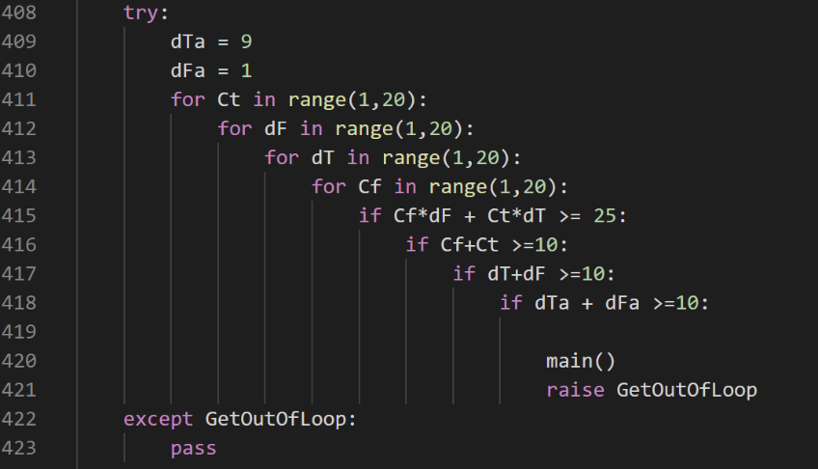

Figure 13

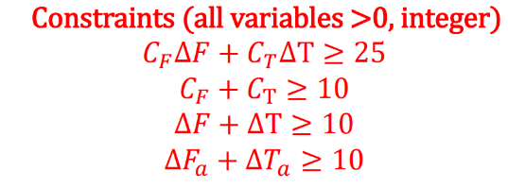

Figure 14



Figure 15

1. **Results**

One of the most optimal combinations of aircraft parameters is attained by running the Python script for Task 2.2 (GP8-path-task2.2.py) (Figure 16).

An example of the most optimal combination of aircraft parameters obtained is as follows.

Cf=16, dF=1, Ct=1, dT=9, dFa=1, and dTa=9, with the total cost generated by the flight be 2307.96.

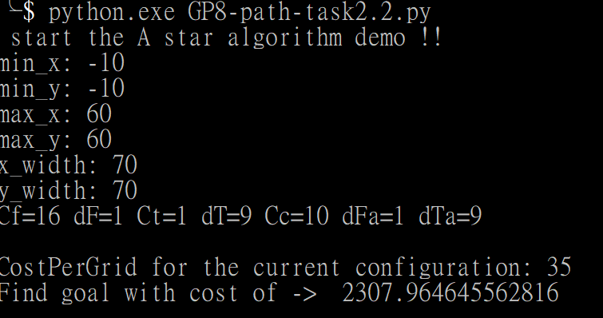

Figure 16

## **Discussion**

Since the task is to tweak the aeroplane parameters within the constraints to obtain the least expensive cost for the map, it is crucial to consider the elements from the map, to avoid brute-forcing the task to obtain the results. Before the importance of such an act was understood, the group tried to implement a mechanism to check for the best combination, testing all possible values. However, the time needed to compute the best results can be minimized by considering the map and the locations of its elements (e.g. the time-consuming area). The calculation of the results then proceeded at a more rapid pace after the map was put into context for the calculation. Therefore, the importance of context cannot be undermined to allow for the efficient calculation of future tasks.

**Task 3: Designing a new cost area that can reduce the cost of the route**

1. **Methodology:**

In task 3, our goal is to design a new minus-cost area(-4*distance) that can reduce the cost of the route with the fixed cost per grid(Cf = 1, F= 1, Ct = 2,T = 5, Cc = 10, Fa = 0.2, Ta = 0.2),  with size of maximum 16 m^2(16 grid point). We believe that the path will not get any big changes after adding the minus-cost area, so we have decided to first generate a path without a minus-cost area, which is a path that similar to task 1, 2.1and  2.2. Then we observed that there is 14 grid point which connected with 2 slopes (-1 and 1), since the distance between two grid points in a slope is square root 2 if we add a minus-cost area under all these grid points, and put the remaining 2 m^2 on the tail of the area, we can get a maximum reduction of -4*(square root 2*14+2) = -87.2.

1. **Result:**

After the simulation, we got the result of 21 costs per grid and found the goal with a cost of 1259.58 by the additional minus-cost area.



1. **Discussion:**

In this task, since the goal is simply to add an area of cost reduction, so we instantly think of making 16 different grid point on all of the slopes, so that we could maximize the reduction. However, what we do not know is that those 16 grid point is not allowed to be separate, so we have to think of the shape and positioning again. Fortunately, the path we generate for the challenge we got only appears 3 slopes, and 2 of them are connected. Therefore, for the final product, the minus-cost area is set up on those 2 slopes.

**Reflective Essay**

Pak Ho CHAN (Parco)

The aviation industry is not only about pilots, aircraft maintenance mechanics, or Air Traffic Controllers, it also includes the flight dispatchers, which plans a flight path for each flight to lower the costs of airlines. The reason I choose the AAE project is that I want to familiarize myself into different areas in aviation. I want to know how various stakeholders in the aviation industry collaborate to boost the development of the entire industry.

In the beginning, I felt so bored with this project. Because of the inconvenient of online teaching, it became so challenging for all of my groupmates to learn new knowledge – coding. I do not understand how Python works; why do the computer can generate a path by itself. Fortunately, some of my groupmates are talented in coding, and they will spend time teaching me the working principle. It is the reason that I made a significant improvement, and I could finish the hold tutorial exercise about coding by myself during the IC lessons after this project. In the meantime, It tells me the importance of team collaboration.

I have learnt how to make use of GitHub to work on this coding project remotely. Under the COVID-19, we cannot group to finish all the tasks frequently. Thus, we have to make use of an online coding collaboration. Also, I have learnt how to make an algorithm design of path planning in an academic level. What I have learnt in this project have broadened my horizons and is very useful in my further studies. I am quite interested in coding now too! I hope there will be more opportunities to have this kind of projects in the future.

Lok Hei NG (Lochlan)

There have been numerous hiccups in my journey of the AAE Freshman Project, but they all have enabled me to better understand Aviation Engineering, to commit to a hard-working attitude in life, and to be aware of the value of a team.

Aviation Engineering is an interdisciplinary field. Never have I been such aware of this fact. Before this project, I hardly thought AE had any relationship with the field of Computer Science. As it turns out, AE has quite a few elements from Computer Science, with path-planning for aircrafts being an example. Not only is the theory of path-planning important in AE, the implementation of path-planning (i.e. programming) is also vital to the successful operation of the large volume of flights in any given day. Since AE is a study that focuses not only on the design and manufacturing of the aircraft, but also the maintenance and operation of aircrafts, it is crucial to apply knowledge from different fields of study to allow for the smooth operation of the backbone of international travel. In this sense, the project has truly refreshed my understanding of AE.

The project has also challenged me to commit to a hard-working and proactive attitude for both university and in life. Learning is a lifelong process, as the saying goes. There will not be a halt in learning so long as life goes on. Therefore, one must constantly enrich one’s self by the ingest of knowledge. One example of this would be the initial difficulty in using various tools used for software development, namely Git and GitHub. If the group and I were not hard-working enough to learn to use the tools, the process of the project would not have been as smooth as it has been. In the future, if I wish to have a successful career in any field, I would have to commit to working hard, and learning continuously for it, as the world changes as new technology is invented and new discoveries are made.

Furthermore, the project has, like any other, highlighted the importance of teamwork in a project. No person is capable of managing each and every task in a group project in a reasonable amount of time. Specialization and cooperation would enable the group to achieve as a whole. In my group for the project, there are people who are better equipped to handle coding and development, while other people are able to design and research for the report in a way the former could not. If the work had been shifted to only one group member, he/she would have been under immense pressure, while the quality of the work would not have been as good, as no one is equipped with handling every part of the project. Therefore, parallelization and cooperation are the key to any successful group project. Without those, the group project would have been ill-fated from the start. With that, I would like to thank each and every group member for the support and cooperation they have given to me and the group.

Kam Ho LEUNG (Howard)

As an engineering student, this AAE Freshman Project is an invaluable experience to hands-on enterprise tools like GitHub. Although it is quite messy in the first place, everyone is not getting used to it, it is chaos every time a groupmate uploading file,” why am I not allowed to upload my selfie?” “why my push is not on the master?” “where is my branch?” “how to merge these .py?” these questions are being asked every single time because we were just do not know why GitHub is this hard to use. But after one to two weeks, the conversation is starting like “I started a pull request, could you take a look ?”, my groupmate and I are getting used to it, it is handier to use GitHub now, it changes from the state of being a disaster to an extremely useful tool on sharing group work. I believe that it would be a great advantage knowing how to use GitHub on the future group project.

It is a hard year to get through, before having this group project, I was warring about making friends or getting no show groupmate, but fortunately, this group project is better than I thought. We have nearly perfect work distributions, we got people who good at paperwork, we have groupmates that skillful in programming, but most importantly, our groupmates are willing to talk and take responsibilities! Everyone has their part, despite some of them are not catching up after absence, but we complete this project with each of us, even though it would be greater if we did not fail that much time while recording the presentation.

I am not complaining to who, but it takes too long on preparing the report and making the video. We initially planned to finalize all of the report and script before 7, and get well prepared for the presentation, then ending the presentation part before 10, but, with all of these mic muting, computer lagging, Microsoft Teams delay, script modifying, Zoom meeting over the time limit, we finally did it at 11:30, just took too long on some minor issues. But with this experience, we will be much more prepared for the next time, we could avoid that meaningless time-wasting.

Overall, this project helps me gathering experience in many circumstances, from actual knowledge to group working, there are things that I could be enhanced, none of the time wastings is wasting, all the time consumed meaningless would be the time that I saved for the next time, and all of these are going to help me get through the future academic work.

Hoi Ki TSANG (Helen)

In reflection on my experience in the AAE Freshman Seminar Project, I have a clear understanding of the design of aircraft path planning algorithms, as well as in what things should include in path planning. There are lots of things need to concern such as distance factors, flight cost and safety.

Moreover, in this project, we learned how to use the programming language and online collaborative programming platform by ourselves. I have accumulated valuable practical experience to use Python to design and develop path planning algorithms for aircraft. Also, I gained practical skills to use Github to work with teammates. There were many incidents. For instance, there was much chaos in the first lesson. Most of the teammates and I could not successfully download the Github and insert the Python because Those things where we did not learn or even know. This was difficult for us to start the first step to use. We learned from the experience and tried to have lesson face to face. After that, learning process became more smooth. I think the most significant things we do not being afraid to go out the confident zone to learn and tackle the problem instead of burying our head in the sand. Another incident happened was the prepare of video. Our group was lucky as all the group members are stay in Hong Kong so we can prepare the video together. There were many difficulties in the preparation. One of the difficulties is that the online video app has limitation on time so we needed to open the online video app again and again. Another difficulty is the duration of the video. There has the restriction of video duration. The video was more than ten minutes at first. After we cut the information of background knowledge and spoke faster, it met the restriction.

Beside of my specific harvest in learning coding, I feel that I learned the most and was most likely to know importance of teamwork. In the project. I faced many challenges and my teammates are kindly to help me. I really appreciated the other students about the work they did and what kind of methods they think and give. I learnt from they and it provided me a better sense of how the path planning designed by python.

Yat Chi KHIM (Jimmy)

The freshman project is overall challenging but also valuable for me. Before the start of the project, I am not familiarize with coding and the use of Github. This require me a while of time for me to understand the meaning of the function of different code in the cooresponding sections. Also participating this projection also help me to know more about the importance and requirements of aircraft route planning. It requires lots of time to calculate in order to find the most suitable and highest efficiency route, during the project, we encounter many problems finding out the answer. It requires a long time to figure out and debug it.

First of all, I think trying to use the Github is the hardest thing for me. Github is new for me and there are many functions. It takes me like weeks to get used to it. During the first and second lectures, many problems happened like we couldn’t connect the Github to our computers, causing a chaos among the team. But overall we figured it out and Successfully finish many tests. Python also cause many problems at the start of the project, there are many codes for different function and all of them are coherent. A small mistake may require a long time to fix it. But I found it interesting for learning to code by trying lots of time. Every task we complete gives lots of joy and help us to continue. I think the use python really help us to explore he use of coding which is meaningful for us in engineering.

Overall it is meaningful for me with the knowledge of coding and the working principle of route planning.

**Reference**

[1] Antonio Franco, Damián Rivas, and Alfonso Valenzuela “Optimal Aircraft Path Planning Considering Wind Uncertainty” Universidad de Sevilla, 2017

[2] Sciencedirect.com. 2020. *Configuration Space - An Overview | Sciencedirect Topics*. [online] Available at: <https://www.sciencedirect.com/topics/engineering/configuration-space> [Accessed 10 November 2020].

[3] Wanmai Yuan, Nuwan Ganganath, Chi-Tsun Cheng, Guo Qing, and Francis C.M. Lau “A Consistent Heuristic for Efficient Path Planning on Mobility Maps”. Hong Kong Polytechnic University, 2017.

[4] Python.org. 2020. *What Is Python? Executive Summary*. [online] Available at: <https://www.python.org/doc/essays/blurb/> [Accessed 10 November 2020].

[5] Tutorialspoint.com. 2020. *Python - Overview - Tutorialspoint*. [online] Available at: <https://www.tutorialspoint.com/python/python_overview.htm> [Accessed 10 November 2020].

[6] Techcrunch.com. 2020. *Techcrunch Is Now A Part Of Verizon Media*. [online] Available at: <https://techcrunch.com/2012/07/14/what-exactly-is-github-anyway/> [Accessed 10 November 2020].

[7] How-To Geek. 2020. *What Is Github, And What Is It Used For?*. [online] Available at: <https://www.howtogeek.com/180167/htg-explains-what-is-github-and-what-do-geeks-use-it-for/> [Accessed 10 November 2020].